Welcome to our weekly newsletter for
Good News for Friday 21st July 2023

Dear Sisters and Brothers in Christ,

Please stay behind after this Sunday’s service so that we can take a picture of the congregation of St Augustine’s with St Luke’s as we don’t have a current photo of the whole congregation!

All change!
We are fast approaching August and the holiday season, so we are making a big change to the weekly newsletter. It will be just one newsletter for the whole month which will contain all the services for the month and when the regular groups are meeting. Come September the weekly newsletter will be back but in a newer ‘trimmer’ format. If you have any queries about these changes, please speak to Victoria in the church office.

All respond!
Please could everyone who received an envelope with information about the Parish Giving Scheme please remember to return their ‘Response Form’ soon. There is a Response box at the back of St Augustine’s church, or you can pass it to a member of staff. All responses will be treated in complete confidence and will only be seen by authorised members of the finance team. Thank you so much.

Prayer
Lead me this day, Lord,
to live fully in the present moment
and enjoy all that is good around me.
During this summertime may I take time
To appreciate your creation and
May all that is life-giving remind me
of your life and love that surround me now,
through Jesus Christ our Lord.
Amen.

God Bless you Revd Steve Spencer & Revd Rachel Winn
This Week Services
7th Sunday after Trinity 23rd July
St Augustine's Church: Southborough Lane, Bickley, BR2 8AT.
10.00am ~ Holy Communion
If you are unable to come this service will be Live-Streamed on our YouTube channel address:
https://youtube.com/channel/UCR70BiHHimXOLZpMSXV44IQ

Please stay behind after this Sunday’s service so that we can take a picture of the congregation of St Augustine’s with St Luke’s as we don’t have a current photo of the whole congregation!

Scripture Reading:
First Reading: Romans 8: 12-25
Gospel Reading: Matthew 13: 24-30, 36-43

Collect – Special Prayer for Today
Generous God,
You give us gifts and make them grow:
Through our faith is small as mustard seed,
Make it grow to your glory
And the flourishing of your kingdom;
Through Jesus Christ our Lord. Amen

Next Week’s Services
8th Sunday after Trinity 30th July
St Augustine's Church Southborough Lane, Bickley, BR2 8AT.
10.00am ~ Morning Worship

Next St Luke’s Service
11th Sunday after Trinity 20th August
5.30pm - Holy Communion

PARISH NEWS AND NOTICES

Capturing the Moment - On Sunday 23rd July we would like to take a picture of the congregation of St Augustine’s with St Luke’s as we don’t have a current photo of the whole congregation!
We would love as many people as possible to be included, so please stay immediately AFTER the morning service on SUNDAY 23rd July.

Tea & Coffee Volunteers
We are looking for some volunteers to do the teas and coffee after church on Sunday 30th July. If you are around and able to help please let the office know.
News from Helen Baker: For those of you not aware Helen Baker is moving to pastures new. She will be heading down to the English Riviera to take up a position of Learning Support Assistant at a school for children and young people with Special Education Needs and Autism. Please join us for her last service on Sunday 13th August and stay for a bring and share lunch afterwards. We wish Helen all the best for her next adventure in life.
There is a card at the back of St Augustine’s Church if you wish to sign it and leave a message and a gift bag if you wish to contribute towards Helen’s leaving gift.

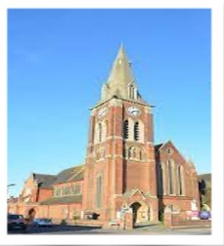
St Luke’s Clock Tower - Time is standing still at St Luke's church; you will note that the spire clock has stopped at 12.00. This is due to a fault with the historic mechanism, and the escapement has been taken away for repair. We hope that it will be ticking again shortly.

Calling all gardeners
Our Memorial Garden is in much need of some regular love and attention! We are looking to gather groups of 2 or 3 people who would work together & be on a rota, in this way it would not be an onerous task and should only come round 3 or 4 times a year. The work is not heavy, mainly weeding & snipping and clipping.
Why not come along on Tuesday 29th August between 10am & 3pm
July Diary
Why not click on the link to download this and join us where you can. Find the July Diary here.

What is on this Week

Youth Connect 22nd July ~ 7.00pm ~ 9.00pm
Outdoor Fun (games and barbecue)
If you are about to start in Year 7 this Autumn why not join our young people for this end of year BBQ and games at St Augustine’s Church; we would love to see you there!
‘5 to the Bar’ is back!
Saturday 22nd July at 7pm
Phil Emery’s jazz group, 5 to the Bar, is back performing and is playing at the Sports Club in Farnborough Village in aid of the RNLI. Enjoy an evening of jazz and support a good cause, too!

Midweek Holy Communion
Wednesday 26th July at 12 Noon
Midweek Holy Communion in St Augustine's Church will take place every second and fourth Wednesday of the month. This is held in the Chapel, and all are welcome.
Please note that during the month of August there will be no Midweek Holy Communion. The next Midweek service will be at midday on Wednesday 13th September.

WELCOME SPACE ~ come and enjoy coffee / lunch & friendship, all welcome: -
Every Thursday, from 11.00am - 4.00pm

Dates For Your Diary
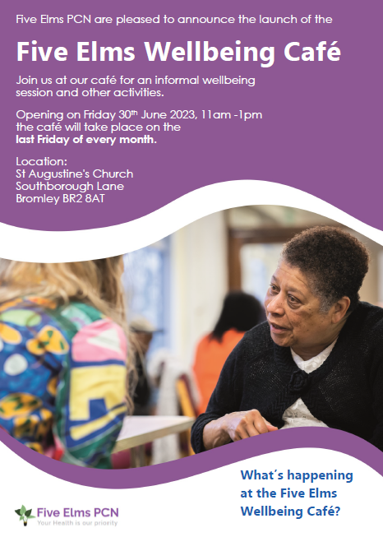
Well being Café
Friday 28th July
This is held at St Augustine's church rooms and will run on the last Friday of every month.

Summer Crafternoon
Saturday 29th July 2-5pm
Pop in anytime during the afternoon for a variety of craft activities for all ages (adults and children). Children under 12 must be supervised by an adult. There will also be a stall selling reasonably priced craft materials. £3 per person or £8 family ticket (2 adults & 2 Children).

Mothers’ Union
Wednesday 9th August Evensong at 5:30pm
Please join us in Rochester Cathedral on as we celebrate the founder of the MU on Mary Sumner Day. There is an exhibition of textiles called Threads of Creation in the Cathedral during August, so this will make or visit special.

Calling Year’s 6-7...
Are you about to begin Year 7 and getting ready for secondary school? If so, this could be for you! This is being held at Jubilee Church, see the flyer for details.

Top of the Pew
Sunday 20th August at 8:00pm
St Augustine’s with St Luke’s take on St Joseph’s in the Garden room. Please come along and support our team.
Forget me not Café
Tuesday 15th August at 1.30pm
This a memory café for anyone with dementia, their families, carers and friends, run by members of the Bromley Common group of churches. For anyone who is needing support because of personal experience or concern about friends or family with dementia and especially for those suffering from dementia and their carers. You are welcome to come along for tea, coffee and cakes available plus a time to relax with a singsong too.
We meet on the third Tuesday of every month at 1.30 pm in the Garden Room.

The ARK Toddler Group – We have finished for the Summer break... next session starts on Wednesday 13th September from 10.00am .
The Ark runs every Wednesday (term time only) at St Augustine's Church. Please use the link below for Eventbrite each week, one ticket per child, tickets on a first come first served basis. If anyone is available to help us set up for our ARK session on Tuesday afternoons at 5pm, please let Helen know.
https://www.eventbrite.co.uk/o/st-augustines-with-st-lukes-church-35212875693

CONFIRMATION SERVICE :
On Sunday 29th October a Confirmation Service by Bishop Jonathan, the Bishop of Rochester, is being held at St John’s Church, Park Road, Bromley. If you are considering being confirmed please speak to a member of Clergy (Steve or Rachel) as we are planning on running a short course for those interested early in the Autumn. Similarly, if you have not been baptised and would like to explore baptism, please speak to us!

Parish Weekend away ~Ashburnham Place
Friday 5th - Sunday 7th January 2024
We have not had a Parish Weekend away for some years. This post pandemic period gives us an ideal opportunity to look afresh at what God may be calling us to do in our parish and enable us to develop a plan together for the next 3-5 years.
Further details including cost available soon. Please do not let the cost become a barrier www.ashburnham.org.uk.

Charity and Community Updates
BROMLEY FOOD BANK ~ do not forget us!
Food Wanted

- Tinned Hot Meat
- Tinned Cold Meat
- Tinned Fruit
- Sugar
- Cooking Sauces
- Desserts, Jelly, Songe Puddings, Angel Delight

The Food Bank has plenty of pasta, cereal, biscuits, banana bread and tea.

PLEASE MAKE SURE ALL FOOD IS IN DATE BEFORE YOU DONATED IT AND DO NOT DONATE ANY CHILLED OR FROZEN ITEMS AS THEY DO NOT HAVE THE CORRECT STORAGE FOR IT.

Keep in touch
Though we are not all able to meet in person, we certainly do not want anyone to feel isolated or alone. If you know anyone who might appreciate a call, do let us know by contacting the Vicar or emailing the Office.
We also have a prayer team, and you can send in prayer requests for yourself or others.
Lastly, if you know of someone who would like to receive our weekly newsletter, then forward this email to them and ask them to sign up here.

Love, prayers and the peace of the Lord Jesus be with you always.

Contact Details
Vicar Rev Steve Spence
07778784331 revsteve.spencer@btinternet.com
Curate Rev Rachel Winn
07311 330202 curaterachel@yahoo.com
Youth & Schools Minister Helen Baker
07576 233119 hbyouthpasty@hotmail.co.uk
Church Warden Hilary Chittock 07884 195700
Church Warden Jeff Blyth 07557 349279
Parish Office 020 8295 1550 office@st-augustines.org.uk
The parish office is open every weekday morning
between 10am – 1pm
Victoria Bouwer Mon, Weds & Fri
Linda Spencer Tues & Thurs
Hall Bookings
St Luke’s bookings@st-augustines.org.uk
St Augustine’s liz@emailcarter.plus.com

Online Donations to St Augustine’s with St Luke’s
There are several ways to donate,
You can donate online to our bank details are 20-14-33 20772100.
Payee Account Name
THE PCC OF THE ECCLESIASTICAL PARISH OF ST AUGUSTINES WITH ST LUKES BROMLEY
Alternatively, you can give via credit or debit card on our Online Web Page
Or use the below QR Code – under the Gift Aid for donations only up to £30
St Augustine's with St Luke's Parish Church is a Registered Charity
(Charity Number 1129375)

