The Parish of St Augustine's with St Luke's
Sharing God's Love
The Parish of St Augustine’s with St Luke’s
Sharing God’s Love

Welcome to our weekly newsletter for
Good News for Friday 06 January 2023

Dear Sisters and Brothers in Christ,
This being the first newsletter of 2023, I would like to wish everyone a Happy New Year. The year ahead is predicted by many to be a difficult year, with high prices, high inflation and the ongoing cost of energy. This is a concern that will affect every part of our community, therefore we will continue to offer week by week on Thursdays a "Warm Space". So people can come and meet with others and share time and fellowship together over tea/coffee, biscuits and hot soup and a roll for lunch. Despite the difficulties that we face, as Christians we have a message to proclaim that the good news of Jesus Christ is for all people, at all times and in all circumstances. Over this Christmas period we have celebrated God spectacularly reaching out to us through his Son Jesus Christ. The narrative of the Christmas message is one of love, whether you are young or old, single or in a relationship. God's love surpasses and transcends all that tries to engulf us, so let that be our message for 2023 God is Love.
Prayer
Father God, let your Holy Spirit
guide us through the ups and downs of 2023
let your light shine upon the
path you have set before us
and may you be ever present
in all that we day by day.
God Bless you
Revd Steve Spencer & Revd Rachel Winn

This Week Services
Baptism of Christ, Sunday 8th January:
St Augustine's Church: Southborough Lane, Bickley, Bromley BR2 8AT.
Morning Worship ~ 10.00am, St Augustine's Church
If you are unable to come this service will be Live-Streamed on our YouTube channel address:
https://youtube.com/channel/UCR70BiHHimXOLZpMSXV44IQ
Collect
Heavenly Father
at the Jordan you revealed Jesus as your Son:
may we recognize him as our Lord
and know ourselves to be your beloved children;
through Jesus Christ our Saviour. Amen
Scripture Readings:
First Bible Reading: Acts 10: 34-43
Second Bible Reading: Matthew 3: 13-17

Next Week’s Services

2nd Sunday of Epiphany, 15th January:
St Augustine's Church Southborough Lane, Bickley, Bromley BR2 8AT.
Holy Communion ~ 10.00am, St Augustine's Church

Next St Luke’s Services
22nd January - Service of Holy Communion at 5.30pm
PARISH NEWS AND NOTICES
Stamps - Don't Forget
As of 31 January 2023 all non-barcoded stamps, which have the Queen's head on, will no longer be valid. So, get hunting around your house to find all the stamps you have tucked away, if you don't use the stamps, you can 'swap them out' details of this and more information can be found here, or you can go to www.royalmail.com/barcodedstamps.
Defibrillator Update ~ we now have the fitted defibrillator!
Many thanks to everyone who has contributed to our Defibrillator Fund. The defibrillator has how been installed and registered on the nation defibrillator network and with the London Ambulance Service. A special mention to the young people at Newstead Wood School who raised a considerable amount of money towards this initiative!
If you would like to donate, there are 3 ways to do so:
• after the service on Sunday via Cash or Card reader
• the QR Code below (maximum £30)
• to the church bank account with a reference of 'Defibrillator'
(our bank details are the end of this newsletter).
Diary:
Why not click on the link to download this and join us where you can? Find the January Diary here.
What is on this Week
The ARK Toddler Group
Starts Wednesday 11th January from 10.00 ~ 11.30am
The Ark runs every Wednesday (term time only) at St Augustine's Church 10.00-11.30am.
Please use the link below for Eventbrite each week, one ticket per child, tickets on a first come first served basis.
https://www.eventbrite.co.uk/o/st-augustines-with-st-lukes-church-35212875693
If anyone is available to help us set up for our ARK session on Tuesday afternoons at 5pm, please let Helen know.
Midweek Holy Communion
Wednesday 11 January at 12 Noon
Midweek Holy Communion in St Augustine's Church, will take place every second and fourth Wednesday of the month. This is held in the Chapel, and all are welcome.
WARM WELCOME SPACE and CAMEO
Thursday 11th January ~ from 10.30am until 4.00pm
Our Warm Welcome Space is for anyone who needs to keep warm during the energy crisis. We are providing this space to meet, work and chat with others during the next few months ~ and we are making many new friends. Offers to make soup also welcome or put tins of soup in the box under the noticeboard.

Dates For Your Diary
Youth Connect - Winter Wonderland
Saturday 14th January - from 7.00pm to 9.00pm
Christmas may be over but there's still a lot of winter fun to be had. Join us for a fun evening of winter themed games, biscuit decorating and food. Open to anyone in year 7 and up.
Merry Pilgrims Walk
Tuesday 17th January at 10.30pm
Walk around Scadbury Park. Meet in the car park off Old Perry Street - postcode BR7 6PT.
Forget me not Café
Tuesday 17th January at 1.30pm
Is a memory café for anyone with dementia, their families, carers and friends, run by members of the Bromley Common group of churches. For anyone who is needing support because of personal experience or concern about friends or family with dementia and especially for those suffering from dementia and their carers. You are welcome to come along for Tea, coffee and cakes available plus a time to relax with a sing-song too
We meet on the third Tuesday of every month at 1.30 pm in the Garden Room.
Mothers' Union
Wednesday 18th January at 2pm
Mothers’ Union will be holding their Annual Meeting followed by a quiz.
Bits and Pieces (Adult Crafts)
Wednesday 18th January at 7.30pm
Lace cut Cards... make beautiful and standout greeting cards with the 'Lace' or 'lattice' cut and weave technique. Open to adults. No skills necessary. £5 for materials.

Charity and Community Updates

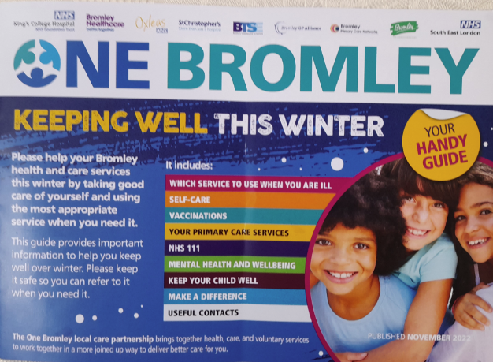
Keeping well this winter:
There will be a few 'One Bromley' guidance leaflets available in St Augustine's Church to give you tips about how to keep well throughout winter; look out for these soon.

BROMLEY FOOD BANK ~ don't forget us!

The Food Bank has plenty of pasta, pulses, cereal, biscuits, Christmas Pudding and tea
PLEASE MAKE SURE ALL FOOD IS IN DATE BEFORE YOU DONAED IT.
PLEASE DO NOT DONATE ANY OUT OF DATE OR FRESH ITEMS

Keep in touch

Though we are not all able to meet in person, we certainly don’t want anyone to feel isolated or alone. If you know anyone who might appreciate a call, do let us know by contacting the Vicar or emailing the Office.
We also have a prayer team and you can send in prayer requests for yourself or others.
Lastly, if you know of someone who would like to receive our weekly newsletter, then forward this email to them and ask them to sign up here.

Contact details
Vicar Rev Steve Spence
07778784331 revsteve.spencer@btinternet.com
Curate Rev Rachel Winn
07311 330202 curaterachel@yahoo.com
Youth & Schools Minister Helen Baker
07576 233119 hbyouthpasty@hotmail.co.uk
Parish Office 020 8295 1550 office@st-augustines.org.uk
The parish office is open every weekday morning
between 10am – 1pm
Victoria Bouwer Mon, Weds & Fri
Linda Spencer Tues & Thurs
Hall Bookings
St Luke’s bookings@st-augustines.org.uk
St Augustine’s liz@emailcarter.plus.com 020 8467 8155
Online Donations to St Augustine’s with St Luke’s
There are various ways to donate,
You can donate online to our bank details are 20-14-33 20772100.
Payee Account Name
THE PCC OF THE ECCLESIASTICAL PARISH OF ST AUGUSTINES WITH ST LUKES BROMLEY
Alternatively you can give via credit or debit card on our Online Web Page
Or use the below QR Code – under the Governments Small Donation Scheme we can only claim 25% Gift Aid for donations only up to £30
St Augustine's with St Luke's Parish Church is a Registered Charity
(Charity Number 1129375

